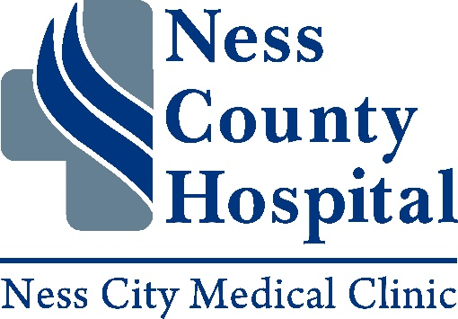

**316 Custer Ness City, KS 67560**

**FAX: (785) 798-3302 PHONE: (785) 798-2233**

**PATIENT LATE ARRIVAL AND NO SHOW POLICY**

At the Ness City Medical Clinic we strive to meet and exceed the expectations of all our patients and we are dedicated to providing you and your family with the best care and services possible. We also strive to meet your needs by providing appointment times that best fit you and your families schedules.

Time is specifically reserved for you on your schedule when you make your appointment. When sufficient notice is not given to cancel or reschedule your appointment, it does not give us enough time to contact another patient who could come to the clinic during your assigned time. This results in other patients not getting the care they need, when they need it.

Because of the great need for our services we have implemented the following Late Arrival and No Show Policy. Patients who arrive more than 10 minutes late for their scheduled appointment time will not be seen and will need to reschedule their appointment for another day.

Ness City Medical Clinic policy states that 3 or more no-shows in a 12 month period will be considered excessive. Patients who have 3 no-show appointments within the preceding 12 month period will be put on Restrictive Access. Restrictive Access means that you or your family member will be removed from any appointments that you have scheduled with us. You will only be allowed to schedule an appointment as the last appointment of the day for the next 6 months.

By implementing this policy, we believe we honor patients who schedule and keep their appointments, while also trying to accommodate everyone in a fair and efficient manner.

I have read and fully understand the Ness City Medical Clinic policy on Late Arrival and No Show appointments.

___________________________________________ ___________________

Patient Signature Date